Dear parents,
Below are some of the things your child should be able to do at the end of this half term.
English: The children are exploring sounds and learning Phonics songs in order to become familiar with initial sounds. The children will also become familiar with the formation of letters and develop their fine motor skills in preparation for writing.
The children will be listening to a wide range of stories. They will be retelling familiar stories and discussing the sequence of the story. (beginning, middle, end)
Maths: The children are beginning to identify shapes and numbers in their environment. They will also be counting out objects accurately and learning number songs to recognise one more and one less when counting.
Understanding the World: At the beginning of Foundation Stage the children have a lot of opportunities to talk about themselves and share their family traditions with the rest of the class. This encourages them to become confident in front of their new classmates and adults in class.
Topic:
Ourselves
Weblinks:  www.topmarks.co.uk  www.phonicsplay.co.uk  www.letters-and-sounds.com | Harry and the Bucketful of Dinosaurs  By Ian Whybrow  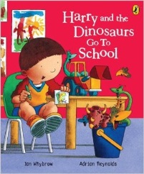  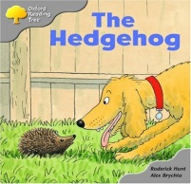  The Hedgehog  Oxford Reading Tree

