Dear parents,
Below are some of the things your child should be able to do at the end of this half term.
English: The children will be using non-fiction books to find out information about Space and the planets. We will also be writing lists of items we would like to take into space with us, using the book ‘Whatever Next’ as a stimulus for this activity and as a theme throughout the Space topic.
We will continue to practise recognising the letter shapes and their corresponding sounds and encouraging your child to apply the knowledge that they have when writing and reading independently. It is important the children are able to read ‘made up words’ accurately as they are tested on these in Year 1. We refer to the made up words as ‘Alien Words’ and there is an interactive game that the children enjoy playing to help them to practise.
As well as hearing your child read it is essential to read aloud to your child. It assists with vocabulary, intonation and expression and it allows your child to access stories and books that they cannot yet read to themselves.
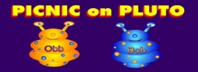

Maths: The children are becoming confident with number activities and we will be looking at addition this half term in class. Encourage your child at home with lots of verbal addition problems around the house. For example, when setting the table for dinner ask your child to put out 4 forks and 4 spoons and then count how many there are altogether.
Understanding the World:
The children will be learning about Space and the planets. We will be listening to songs about the planets to help your child with remembering the unusual planet names. The children will also be creating their own ‘Space’ role play resources such as; building rockets and spaceships using a variety of construction materials and finding objects that they can use to create their own astronaut suit (e.g. a colander as a helmet / wellingtons as space boots!)
Topic:
Space
Weblinks:  www.topmarks.co.uk  www.phonicsplay.co.uk  www.letters-and-sounds.com | 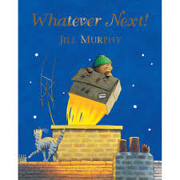  Books we will be looking at;  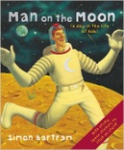  Whatever Next  By Jill Murray  Aliens Love Underpants  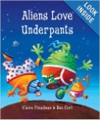  By Claire Freedman  Man on the Moon  By Simon Bartram

