Dear parents,
Below are some of the things your child should be able to do at the end of this half term.
English: Our topic for this half term will be ‘Fantasy’. During this topic we will be looking closely at a number of books and their features, including the front cover, title page and the structure of the book (beginning, middle and end). The children will be re-writing stories and creating their own stories as well as creating characters.
To help your child with this topic you can discuss these features when sharing books at home and even encourage your child to role-play their favourite stories. You might want to use props that you find around the house.
Please continue to practise recognising the letter shapes and their corresponding sounds. Encourage your child to apply the knowledge that they have when reading and writing independently.

Maths: This half term the children will be revisiting how to subtract two single digit numbers and they will be counting back to find the answer e.g. There are five sweets and Ben took 2, how many are left?
They will be identifying and sorting money. Please encourage your child to purchase items themselves when shopping using the language related to money. They will be investigating measuring in different ways e.g. how many steps does it take to cross the playground, how many cubes long is the table etc.
The children will also be looking at doubling and halving, shape and identifying shapes in the environment.

Understanding the World: The children will be using a range of technology within the setting. They will also being looking closely at similarities and differences in alternate environments.
Topic:
Fantasy
Weblinks:  www.topmarks.co.uk  www.phonicsplay.co.uk  www.letters-and-sounds.com | Books we will be looking at:  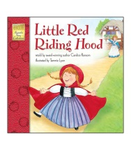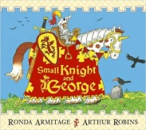  Little Red Riding hood Small Knight and George  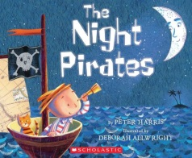The Night Pirates by Peter Harris

