



Mathematics CalculationPolicy

At Engayne Primary School, we believe that children should be introduced to the process of calculation through practical, oral and mental activities. As children begin to understand the fundamentals of mathematics, they develop ways of supporting their thinking and calculation methods by: using the requisite methods that apply to the applicable scenario, learning to interpret and use the signs and symbols involved within written and reasoning calculations. Children will normally progress from concrete methods to pictorial ones before using abstract techniques.

Written methods are complementary to mental methods and should not be seen as a separate entity. The aim is that children use mental methods when appropriate, but for calculations that they cannot do in their heads they can use an effective written method accurately and confidently.

By the end of Year 6, children should be able to choose an efficient method (mental or written) that is appropriate to a given task.

This calculation policy has been written in line with the programmes of study taken from the revised National Curriculum for Mathematics (2014). It provides guidance on appropriate calculation methods and progression. The content is set out in yearly blocks under the following headings: addition, subtraction, multiplication and division. Statements taken directly from the programmes of study are listed in bold at the beginning of each section. It has been written to ensure consistency and progression throughout the school and reflects a whole school agreement.

Please note that early learning in number and calculation in Reception follows the 'Development Matters' EYFS document, and this calculation policy is designed to build on progressively from the content and methods established in the Early Years Foundation Stage.

**Aims of the Policy**

• To ensure consistency and progression in our approach to calculation.

• To ensure that children develop an efficient, reliable, formal written method of calculation for all operations.

• To ensure that children can use these methods accurately with confidence and understanding.





Addition



|  |  |
| --- | --- |
| **ENGAYNE PRIMARY SCHOOL**  **CALCULATIONPOLICY** | |
| **ADDITION** | |
| **EYFS** | |
| **VOCABULARY:** add, more, and, make, sum, total, altogether, score, double, one more, two more, ten more…, how many more to make…?, how many more is…than…? | |
| **Method** | **Example/Representation** |
| Using a range of practical resources and real life contexts, pupils develop their understanding of the concept of addition through counting activities. | How many dinosaurs are there?    What about if I give you two more? How many are there now? |
| Children are introduced to the addition symbol (+) and use pictures/ diagrams to represent the calculation. | There are 2 birds. Another bird flies in. How many are the real together? |
| Store the larger number mentally and use fingers to count on. | Count on from the larger number. A child will choose the larger number, even when it is not the first and count on from there; (5 in your head) ‘six, seven, eight ’using their fingers:  3+5=8 |
| Children represent an addition number sentence in picture form and are able to solve simple addition number sentences using objects or fingers. Children will begin to explain their reasoning. | 5 + 2 = 7  5+2= 7 |
| **MENTALSTRATEGIES:**   * Develop a mental image of the number system. * Understand the value of a number. * Counting forwards and backwards. * Recall of number bonds to 10. * Say which number is one more or than a given number to 20. | |

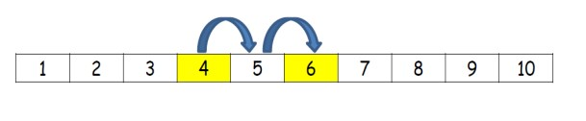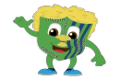



|  |  |  |  |  |  |  |  |
| --- | --- | --- | --- | --- | --- | --- | --- |
| **YEAR1** | | | | | | | |
| **VOCABULARY:** number bonds, add, more, plus, make, sum, total, altogether, inverse double, near double, equals, is the same as (including equals sign), score, one more, two more… ten more, how many more to make…?, how many more is…than…?, how much more is…? | | | | | | | |
| **Method:** | **Example/Representation:** | | | | | | |
| Children will be taught to use a number track to support addition. | 4+2= 6 | | | | | | |
| Bead strings and counting sticks will be used to support addition. | 5+3= 8 | | | | | | |
| Children will use a prepared number line to solve simple addition stories and number sentences. | 2+5= 7 | | | | | | |
| Children will be taught how to solve simple addition stories with the support of a 100 number square. | 11+7=18 | | | | | | |
| Children are taught how to use a blank number line for addition and then encouraged to draw their own number line to help solve problems. | 12+7=19  I I II  13 + 14 = 27  X X X  X X X  X X X  X X  X  X  X | | | | | | |
| Children will partition numbers into tens and units using the | 10 |  | 1 |  | 10 |  | 2 |
| rods and crosses method when adding two2-digitnumbers |
| that lie within the tens boundary. |
|  | 11 |  | + |  | 12 | =23 |
|  |  |  |  |  |  | = 23 |
| Children will solve one-step addition problems using concrete objects and/or pictorial representations. | I have 5 sweets and I am given 3 more. How many do I have altogether? | | | | | | |
| Children will use number trios when recalling number bonds to twenty and solving one step problems involving addition to twenty. |  | | | | | | |
| **MENTALSTRATEGIES:**   * Know addition can be carried out in any order (commutative). * Add 1 and 2 digit numbers to 20 including 0. * Number bonds to 20. * Doubles of numbers up to and including double 10. * Adding 10 to a single digit number. * Identify 1 more than a given number. | | | | | | | |

|  |  |
| --- | --- |
| **YEAR 2** | |
| **VOCABULARY:** add, addition, more, plus, make, sum, total, altogether, score, double, near double, one more, two more… ten  more… one hundred more, how many more to make…?, how many more is… than…?, how much more is…?, tens boundary | |
| **Method:** | **Example / Representation:** |
| Children will use concrete objects (dienes rods) and pictorial representations (rods and crosses) to add: a 2-digit number and units, three 1-digit numbers and a 2-digit number and multiples of 10. | I I II  13 + 14 = 27  X X X  X X X  X X X  X X  X  X  X |
| Children will partition numbers into tens and units when adding two 2-digit numbers that cross the tens boundary. |
| Children begin to set out TU + TU (that lie within the tens boundary) in columns and record as expanded column addition. |  |
| Children begin to set out TU + TU (that cross the tens boundary)  in columns and record as expanded column addition. |  |
| Children begin to set out TU + TU (that cross the tens boundary)  in columns and record as column addition. |  |
| Children begin to set out TU + TU (that cross the hundreds boundary) in columns and record as column addition. |  |
| Children will solve simple addition problems using concrete objects and pictorial representations, including those involving number, quantities and measures. | George has 14 strawberries and Jess has 12 strawberries. How many strawberries are there altogether? |
| **MENTAL STRATEGIES:**  - Know that addition is the inverse of subtraction  - Add numbers mentally, including:   * A 2-digit number and units * A multiple of 10 to a 2-digit number * Two 2-digit numbers * Three 1-digit numbers   - Use knowledge of inverse to check calculations and solve missing number problems  - Use knowledge of number bonds to 10 to calculate numbers bonds to 100  - Count on in tens from any given number (e.g 19 – 29 – 39 – 49 etc) | |

|  |  |
| --- | --- |
| **YEAR 3** | |
| **VOCABULARY:** add, increase, total, plus, sum, more, altogether, column addition, estimate, inverse, double, near double,  one more, ten more… one hundred more, how many more to make …? how many more is… than …? how much more is…?, tens  boundary, hundreds boundary | |
| **Method:** | **Example/Representation:** |
| Children set out HTU + U (that lie within the tens boundary) in columns and record as column addition. |  |
| Children set out HTU + TU (that lie within the tens boundary) in columns and record as column addition. |  |
| Children set out HTU + TU (that cross the tens boundary) in  columns and record as column addition. |  |
| Children set out HTU + TU (that cross the hundreds boundary) in columns and record as column addition. |  |
| Children set out HTU + TU (that cross the hundred and tens  boundaries) in columns and record as column addition. |  |
| Children set out HTU + HTU (that cross the tens boundary) in  columns and record as column addition. |  |
| Children set out HTU + HTU (that cross the tens and hundreds boundaries) in columns and record as column addition. |  |
| Children will solve one and two-step addition problems (including missing number problems) using concrete objects and pictorial representations. | This number triangle has missing numbers. The numbers  along each edge must add up to 90. Put all the numbers:  20, 30, 50 and 60 in the circles to make the totals correct. |

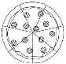

|  |  |  |  |  |
| --- | --- | --- | --- | --- |
| Pupils practise adding fractions with the same denominator |  |  |  |  |
| through a variety of increasingly complex problems to improve |
| fluency. | 5/7 + 1/7 = 6/7 | |  |  |
|  |  | + | = |
| **MENTALSTRATEGIES:**  - Add numbers mentally, including:   * a three-digit number and a single digit number * a 3-digit number and multiples of 10 * a 3-digit number and multiples of 100   + Estimate the answer to a calculation and use inverse operations to check answers.   + Know number pairs that total 1000 (multiples of 100).   + Calculate 10 or 100 more than any given number. | | | | |



|  |  |
| --- | --- |
| **YEAR4** | |
| **VOCABULARY:** add, addition, more, plus, increase, sum, total, altogether, score, double, near double, tens boundary, hundreds boundary, thousands boundary, inverse | |
| **Method:** | **Example/Representation:** |
| Children will add numbers with up to 4-digits using the formal written methods of column addition. |  |
| Solve two-step problems using formal jottings and explaining reasoning behind their calculations (Singapore Bar method). | Seb has 77cubes. He builds two towers.  One tower uses 18 cubes and one tower uses 35 cubes. How many cubes does he have left over?    3/4 + 3/4 = 6/4 |
| Pupils continue practise in adding fractions with the same denominator to become fluent through a variety of increasingly complex problems beyond one whole. | + |
| **MENTALSTRATEGIES:**  - Add numbers mentally, including:   * a four digit number and multiples of one thousand * Use knowledge of doubles to derive related facts (e.g 15+ 16=31 because 15+15=30 and 30+1=31) * Know number pairs that total 1000 (multiplesof10) * Estimate the answer to a calculation and use inverse operations to check answers | |

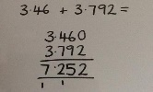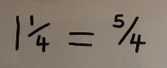

|  |  |
| --- | --- |
| **YEAR5** | |
| **VOCABULARY:** Efficient written method, add, addition, more, plus, increase, sum, total, altogether, score, tens boundary, hundreds boundary, thousands boundary, units boundary, tenths boundary, inverse | |
| **Method:** | **Example/Representation:** |
| Children will add numbers with more than 4-digits using the formal written method of column addition. |  |
| Children will add decimal numbers with the same number of decimal places using the formal written method column addition. |  |
| Children will add decimal numbers with a different number of decimal places using the formal written method column addition using 0 as a place value holder. | Zero used as a place value holder. |
| Solve multi-step problems (that may include subtraction) using formal jotting sand explaining reasoning behind their choice of operation and calculation (Singapore Bar Method). |  |
| Recognise mixed numbers and improper fractions and convert from one to the other. |  |
| Practise adding fractions (with different denominators) where calculations exceed one as a mixed number |  |
| **MENTALSTRATEGIES:**   * Add numbers mentally with increasingly large numbers (e.g 10,162+2,300=12,462) * Mentally add tenths (e.g 0.2 +0.6= 0.8) and 1-digit whole numbers and tenths (8+ 0.3 =8.3) * Use number bonds to 100 knowledge to calculate complements to one using hundredths (e.g0.83+0.17=1) * Use rounding to check answers to calculations and determine, in the context to a problem, levels of accuracy | |

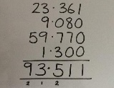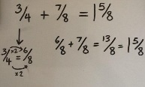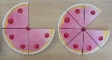

|  |  |
| --- | --- |
| **YEAR6** | |
| **VOCABULARY:** order of operations, column addition, add, in total, answer, tens boundary, hundreds boundary, thousands boundary, millions boundary, units boundary, tenths boundary, hundredths boundary, decimal place, inverse | |
| **Method:** | **Example/Representation:** |
| Children will add several numbers of increasing complexity up to ten million. | 81,059+3,668 +15,301+20,551 =120,579 |
| Children will add several decimal numbers with a different number of decimal places. | 23.361 +9.08 +59.77+1.3= 93.511  Zero used as a place value holder. |
| Solve multi-step problems (that may include subtraction) using formal jottings and explaining reasoning behind their calculations (Singapore Bar Method) |  |
| Add fractions and mixed numbers with different denominator using the concept of equivalent fractions. |  |
| **MENTALSTRATEGIES:**   * Add numbers mentally with increasingly large numbers (e.g10,162+2,300=12,462) * Add decimal numbers mentally (up to 2 decimal places) * Use estimation to check answers to calculations and determine, in the context of a problem, levels of accuracy. | |





Subtraction

|  |  |
| --- | --- |
| **ENGAYNE PRIMARY SCHOOL**  **CALCULATIONPOLICY** | |
| **SUBTRACTION** | |
| **EYFS** | |
| **VOCABULARY:** take (away), leave, how many are left/left over?, how many have gone? ,one less, two less… ten less…,how many fewer is…than…?, difference between, is the same as | |
| **USEFULVIDEOS:** | |
| **Method** | **Example/Representation** |
| Using a range of practical resources and real life contexts, pupils develop their understanding of the concepts of subtraction as taking away through counting activities. | I had 8 sweets and I ate 2. How many have I got left? |
| Children will use counting objects, toys or their fingers to answer simple subtraction number sentences. | (e.g.6-3=3) |
| Children will listen to a subtraction story and draw a set of objects (jottings) on white boards and cross some off (drawing a picture helps children to visualise the subtraction). |  |
| Children will use their fingers to help with subtraction. E.g.5– 2=  3.They will hold up five on one hand, two on the other, and simultaneously fold them down to find their solution. |  |
| **MENTALSTRATEGIES:**   * Develop a mental image of the number system * Children count backwards using familiar number rhymes (e.g ‘10 Green Bottles’, ‘5 Fat Sausages’) * Count backwards from different starting points * Say which number is 1 less than a given number to 20 | |



|  |  |
| --- | --- |
| **YEAR1** | |
| **VOCABULARY**: subtract, takeaway, minus, leave, how many fewer is…than..?, how much less is..? half, halve, how many are left/left over?, how many are gone?,one less,two less, ten less…, how many fewer is…than…?, how much less is…?=, equals, sign, is the same as,count on, count back, difference between. how many more is…than..?, how much more is..? | |
| **Method:** | **Example/Representation:** |
| Children will be taught to use a number track to support subtraction by counting backwards. | 6–2=4 |
| Bead strings and counting sticks will be used to support subtraction by counting backwards. | 8–3=5 |
| Children will use a prepared number line to solve simple subtractions to respond to number sentences by counting backwards. | 7–4=3 |
| Children will be taught how to solve simple subtractions with the support of a 100 number square. | 20–4=16 |
| Children are taught how to use a blank number line for subtraction (counting forwards) and then encouraged to draw their own number line to help solve problems.  Children will begin with TU–U that lie within the tens boundary then move on to TU –U that cross the tens boundary, |  |
| Children will solve one-step subtraction problems (including missing number problems) using concrete objects and pictorial representations. |  |
| MENTALSTRATEGIES | |
| * Subtract 1 and 2 digit numbers to 20 including 0 * To know that subtraction is not commutative and that the larger number must always come first * Use knowledge of number bonds to 10 and 20 to reason (9+1=10 so 10– 9=1 and 10 – 1=9) | |

|  |  |
| --- | --- |
| **YEAR 2** | |
| **VOCABULARY:** subtract, minus, leave, how many are left/left over?, how many less is… than…?, how much fewer is…?, difference  between, half, halve, equals, sign, is the same as, partition, inverse, count on , count back, one less, ten less… one hundred less. | |
| **Method:** | **Example/Representation:** |
| Children use rods and crosses method when solving TU – TU problems, include those which cross the tens barrier. | **\\CL2K8SRV01\mbaker34.311$\My Pictures\maths.png** |
| Children begin to set out TU - TU (that lie within the tens  boundary) in columns and record as column subtraction. Dienes rods can be used as a concrete learning aid. |  |
| Children begin to set out TU - TU (that cross the tens boundary) in columns and record as column subtraction with decomposition. Dienes rods can be used as a concrete learning aid. |  |
| Children will use their knowledge of difference to use a blank  number line to count on from the smallest number to the largest  number (in tens and units) to solve subtraction number sentences  (TU – TU). |  |
| Children will be encouraged to draw their own number line and begin to decide on the most efficient strategy: whether to start with the smaller number and count on or start with the larger number and count back. |  |
| Recognise and use inverse relationship between addition and  subtraction and use this to check calculations and solve missing  number problems. | **84 – 56 = __**  **84 - __ = 56**  **56 + __ = 84** |
| Children will solve one and two-step subtraction problems using  concrete objects and pictorial representations including those  involving number, quantities and measures. |  |
| **MENTAL STRATEGIES:** | |
| - To know that subtraction is the inverse of addition  - Use knowledge of inverse to check calculations and solve missing number problems  - Subtract numbers mentally, including:  ▪ subtracting units from a 2-digit number  ▪ subtracting a multiple of 10 from a 2-digit number  ▪ subtracting a 2-digit number from another 2-digit number  - Recall and use subtraction facts to 20 fluently  - Use knowledge of number bonds to 100 (multiples of 10) to reason (40 + 60 = 100 so 100 – 60 = 40 and 100 – 40 = 60) | |

|  |  |
| --- | --- |
| **YEAR 3:** | |
| **VOCABULARY:** leave, subtract, less, minus, column subtraction, inverse, decomposition, exchange, how many are left/left  over?, difference between, how many more/fewer is… than…?, how much more/less is…?, Is the same as, equals, sign. multiples of  tens and hundreds. | |
| **Method:** | **Example / Representation:** |
| Children begin to set out HTU - TU (that lie within the tens  boundary) in columns and record as column subtraction. |  |
| Children begin to set out HTU - TU (that cross the tens boundary)in columns and record as column subtraction with decomposition. |  |
| Children begin to set out HTU - TU (that cross the hundreds  boundary) in columns and record as column subtraction with  decomposition. |  |
| Children begin to set out HTU - TU (that cross the hundreds and tens boundary) in columns and record as column subtraction with decomposition. |  |
| Children begin to set out HTU - HTU (that cross the hundreds and tens boundary) in columns and record as column subtraction with decomposition. |  |
| Children will solve one and two-step subtraction problems (including missing number problems). |  |
| Children practise subtracting fractions with the same denominator through a variety of increasingly complex problems to improve fluency. | 5/7 - 1/7 = 4/7 |
| **MENTAL STRATEGIES:** | |
| - Subtract numbers mentally, including:   * Subtracting a single digit number from a 3-digit number * Subtracting a multiple of 10 from a 3-digit number * Subtracting a multiple of 10 from a 3-digit number   - Estimate the answer to a calculation and use inverse operations to check answer | |



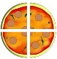

|  |  |  |
| --- | --- | --- |
| **YEAR4** | | |
| **VOCABULARY:** subtract, subtraction, minus, *decrease,* leave, how many are left/leftover?, difference between, how many more/fewer is… than…?, how much more/less is…?, Is the same as, equals, sign. Column subtraction, decomposition, exchange, multiples of thousand, inverse. | | |
| **Method:** | | **Example/Representation:** |
| Children will subtract numbers with up to 4 digits using the formal written method of column subtraction with decomposition. |  | |
| Solve two-step problems using formal jottings and explaining reasoning behind their choice of operation and calculations (Singapore Bar Method). |  | |
| Pupils continue practise in subtracting fractions with the same denominator to become fluent through a variety of increasingly complex problems beyond one whole. | 6 3 3  / - /= /  4 4 4  = | |
| MENTALSTRATEGIES: | | |
| * Subtract numbers mentally, including: * Subtracting multiples of one thousand from a 4-digit number * Use of number pairs that total 1000 (multiples of 10) to calculate subtraction (e.g1000–300=700) * Estimate the answer to a calculation and use inverse operations to check answers | | |





|  |  |  |  |  |
| --- | --- | --- | --- | --- |
| **YEAR5** | | | | |
| **VOCABULARY:** efficient written method, subtract, subtraction, minus, decrease, difference between, inverse, decimals, units and tenths boundary,column subtraction, decomposition, exchange. | | | | |
| **Method:** | **Example/Representation:** | | | |
| Children will subtract numbers with more than 4-digits using the formal written method of column subtraction with decomposition. |  | | | |
| Children will subtract decimal numbers with the same number of decimal places with decomposition. |  | | | |
| Solve multi-step problems using formal jottings and explaining reasoning behind their calculations (Singapore method?) |  | | | |
| Practise subtracting fractions (with different denominators) where calculations exceed one as a mixed number. | 3  1/-  4 | 2  /=1  4 | 1  /  4 | |
|  |  |  | = |
| MENTALSTRATEGIES: | | | | |
| * Subtract increasingly large numbers mentally (e.g12,654–1,341=11,213) * Mentally subtract tenths (e.g0.7 - 0.5=0.2) and 1-digit whole numbers and tenths (8- 0.3=7.7) * Use rounding to check answers to calculations and determine, in the context of a problem, levels of accuracy | | | | |

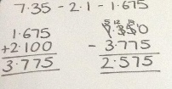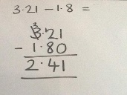

|  |  |
| --- | --- |
| **YEAR6** | |
| **VOCABULARY:** order of operations, subtract, decrease, difference, inverse, decimals, units ,tenths and hundredths boundary, column subtraction, decomposition, exchange. | |
| **Method:** | **Example/Representation:** |
| Children will subtract several numbers (up to ten million) of increasing complexity and be taught to combine some of the numbers so that the subtraction can be completed. |  |
| Children will subtract decimal numbers with a different number of decimal places with decomposition. | Zero used as place holder |
| Children will subtract several decimal numbers with a different number of decimal places and be taught to combine some of the numbers so that the subtraction can be completed. | Zero used as place holder |
| Solve multi-step problems using formal jottings and explaining reasoning behind their calculations (Singapore method?) |  |
| Subtract fractions and mixed numbers with different denominators using the concept of equivalent fractions. |  |
| **MENTALSTRATEGIES:** | |
| * Subtract increasingly large numbers mentally (e.g 12,654–1,341=11,213) * Subtract decimal numbers mentally (up to 2 decimal places) * Use estimation to check answers to calculations and determine, in the context of a problem, levels of accuracy. | |





Multiplication

|  |  |
| --- | --- |
| **ENGAYNE PRIMARY SCHOOL**  **CALCULATIONPOLICY** | |
| **MULTIPLICATION** | |
| **EYFS** | |
| **VOCABULARY:** group, lots of, double | |
| **Method** | **Example/Representation** |
| Children will count groups of the same number of objects and add them together. The children learn about grouping in practical contexts and through pictorial representations. | Count groups of 2 and then count all objects to add them together. |
| Children will solve simple problems involving doubling. | Double 4 is 8 |
| **MENTALSTRATEGIES:**   * Develop a mental image of the number system. * Understand the value of a number * Counting in 2s, 5s and 10s. * Number patterns on a number line and on a hundred square – 2’s, 5’s and 10’s. | |

|  |  |
| --- | --- |
| **YEAR1** | |
| **VOCABULARY:** odd, even, count in twos, fives, count in tens (forwards from/backwards from), how many times?  Lots of, groups of, once, twice, five times, ten times, multiple of, times, multiply, multiply by, array, row , column, double. | |
| **Method:** | **Example/Representation:** |
| Children will count groups of the same number of objects and add them together. The children learn about grouping in practical contexts, through pictorial representation.  Bead strings and counting sticks will be used to support counting in sequences of 2s, 5s and 10s. | 1) I have 5 pairs of socks in the bag. How many socks are there? |
| Children will recognise and complete patterns and sequences involving multiples of 2, 5 and 10. |  |
| Children will be given one-step word problems to solve, involving counting in multiples of 2, 5 and 10 and doubles. Children will use concrete objects and pictorial representations to support their ideas. | Alfie, Joseph and Ben all have a pair of socks. How many socks are there altogether? |
| Children will be introduced to an array to support multiplication | 5+5+5=15 |
| **MENTALSTRATEGIES:**   * Count forwards and backwards in multiples of 2s, 5s and 10s. * Recall doubles of numbers up to and including 10. | |



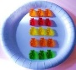

|  |  |
| --- | --- |
| **YEAR2** | |
| **VOCABULARY:** odd, even, twos, fives, tens, threes, lots of, groups of, once, twice, three times, five times, ten times, multiple of, times, multiply, multiply by, repeated addition, array, row, column, double. | |
| **Method:** | **Example/Representation:** |
| Children will be able to recognise and write the multiplication symbol (x) in mathematical statements. |  |
| Children will understand the operation of multiplication as repeated addition on a blank number line and will use practical resources to support this. | 4x5= 15 |
| Children will be able to represent a multiplication calculation using an array and write the multiplication symbol within a number sentence. Children will also understand that multiplication can be carried out in any order (commutative). | 3 x 5=15  5 x 3=15 |
| Children will solve one-step multiplication problems (including missing number problems) using concrete objects and pictorial representations. | I have 3 ladybirds with 5 spots each. How many spots do they have altogether? |
| Children will learn to calculate doubles of 2-digit numbers through partitioning. |  |
| **MENTALSTRATEGIES:**   * Count forwards and backwards in multiples of 3. * Know the 2, 5 and 10 times tables(in and out of order) * Recognise odd and even numbers | |

|  |  |
| --- | --- |
| **YEAR3:** | |
| **VOCABULARY:** multiply, times, groups of, equal groups of, multiple of, multiplied by, estimate, inverse, grid multiplication,  expanded column multiplication, partition, commutative, associative, product. | |
| **Method:** | **Example / Representation:** |
| Children will be taught to multiply numbers (TU x U) through partitioning and the formal written method of grid multiplication. |  |
| Children will be taught to multiply numbers (TU x U) using the  formal written method of expanded column multiplication and  make the link to grid method. |  |
| Children will solve problems involving multiplication, including  scaling. | If a boy is one metre tall, and his Dad is 3 times bigger, how tall is Dad? |
| **MENTAL STRATEGIES:**  - Count forwards and backwards in multiples of 4, 8, 50 & 100  - Know the 3, 4 and 8 times tables (in and out of order)  - Connect the 2, 4 and 8 times tables through doubling  - Use knowledge of place value to calculate multiplication (e.g. 2 x 2 = 4, 2 x 20 = 40, 2 x 200 = 400)  - Double unitary numbers | |

|  |  |
| --- | --- |
| **YEAR4** | |
| **VOCABULARY:** multiply, multiplied by, product, short multiplication, partition, distributive law, commutative, groups of, multiply, times, multiples, inverse | |
| **Method:** | **Example/Representation:** |
| Children will be taught to multiply numbers (TUxU) by partitioning the 2-digit number and using two short multiplications along with addition to solve the problem (Distributive Law). |  |
| Children will be taught to multiply numbers (TU x U) using the formal written method of short multiplication and will link with the Distributive Law method. |  |
| Children will be taught to multiply numbers (HTU & U) by partitioning the 3-digit number and using two short multiplications along with addition to solve the problem |  |
| Children will be taught to multiply numbers (HTU x U) using the formal written method of short multiplication and will link with the Distributive Law method. |  |
| Solve problems involving multiplying and adding to multiply two or three-digit numbers by one digit. | Harriet has 7 friends who each have 24 apples. Joseph has 3 friends who each have 27 apples. How many apples do Harriet and Joseph’s friends have altogether? |
| **MENTALSTRATEGIES:**   * Know all times tables up to and including 12x12(by the end of Year4) * Recognise and use factor pairs(e.g factor pairs for numbers up to and including 10) * Know thatTUx5 is TU x 10 then divide by2 (e.g18x5= (18 x10)÷ 2=90) * Know that TU x9 is TUx10 then subtract TU (e.g 18x9 =(18x10)– 18=162) * Multiply 3 different numbers | |





|  |  |
| --- | --- |
| **YEAR5** | |
| **VOCABULARY:** composite numbers, prime number, prime factor, cube number, square number, derive, factor pairs, formal written method, times, multiply, multiplied by, multiple of, product, short multiplication, partition, long multiplication, scaling, decimal place, units, tenths and hundreds. | |
| **Method:** | **Example/Representation:** |
| Children will be taught to multiply numbers (TUxTU) by partitioning the second 2-digit number and using two short multiplications along with addition to solve the problem. |  |
| Children will be taught to multiply numbers (TUxTU) using the formal written method of long multiplication. |  |
| Children will be taught to multiply numbers (HTUxTU) using the formal written method of long multiplication. |  |
| Children will be taught to multiply numbers (ThHTUxU) using the formal written method of short multiplication. |  |
| Children will be taught to multiply numbers (ThHTUxU) using the formal written method of long multiplication. (Children can also use this method to multiply decimals) |  |
| Children will learn to multiply whole numbers and those involving decimals by 10, 100 and 1000 by moving the digits around the fixed decimal on a place value grid. |  |
| Children will solve problems involving multiplication, including scaling. | Alfie runs 3400m on Sports Day. His friend, Harry, runs three times as far. How far does Harry run? |
| With the use of materials and diagrams, pupils will multiply proper fractions and mixed numbers by whole numbers | 1 x2= 2  4 4  1 2  1 x2=2  4 4 |

**MENTALSTRATEGIES:**

* Recognise and calculate factor pairs for any number
* Use times table knowledge to derive multiples of any number
* Establish whether a number is a prime number (upto100) or a composite number(not prime) and recall prime numbers up to 19
* To know what a square number is and recall all square numbers (up to and including 144)
* To know what a cube number is and recall the first 5 cube numbers

|  |  |
| --- | --- |
| **YEAR6** | |
| **VOCABULARY:** common factors, multiples**,** prime, formal written method, multiply, multiplied by, multiple of, product, short and long multiplication, partition, scaling, decimal place, units, tenths and hundreths. | |
| **USEFULVIDEOS:** | |
| **Method:** | **Example/Representation:** |
| Multiply numbers by 10, 100 and 1000 where the answers are up to three decimal places. |  |
| Multiply one-digit numbers with up to two decimal places by whole numbers using:   * Short multiplication when multiplying by a single digit * Long multiplication when multiplying by a 2-digit number |  |
| Multiply multi-digit numbers up to 4 digits by a 2-digit whole number using the formal written method of long multiplication. |  |
| Multiply simple pairs of fractions, writing the answer in its simplest form. |  |
| Pupils use their understanding of the relationship between unit fractions and division to work backwards by multiplying a quantity that represents a unit fraction. |  |
| **MENTALSTRATEGIES:**   * Identify common factors, common multiples and prime numbers * Use common factors to simplify fractions mentally * Use estimation to check answers to calculations and determine, in the context of a problem, levels of accuracy | |





Division

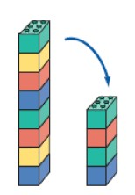

|  |  |
| --- | --- |
| **ENGAYNE PRIMARY SCHOOL**  **CALCULATIONPOLICY** | |
| **DIVISION** | |
| **EYFS** | |
| **VOCABULARY:** halve, half, share, share equally, groups | |
| **USEFULVIDEOS:** | |
| **Method:** | **Example/Representation:** |
| Children experience early division by sharing objects and counting how many in each group/ |  |
| Children will solve problems including halving and sharing. | What is half of 8? Half of 8 is 4 |
| To understand what the division symbol is. | ÷ |
| **MENTALSTRATEGIES:**   * Develop a mental image of the number system. * Understand the value of a number | |

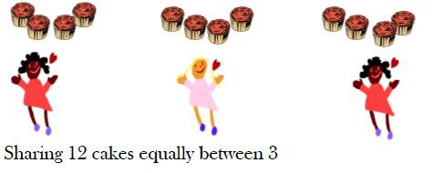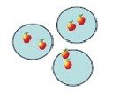



|  |  |
| --- | --- |
| **YEAR1** | |
| **VOCABULARY:** halve, share, share equally, groups, equal groups of, divide, divided by, left, left over | |
| **Method** | **Example/Representation:** |
| Children will understand equal groups and share items out in play scenarios. | Share 12 cakes between 3 people equally: |
| Children will be taught to associate ‘half ’with dividing by two and recognise, find and name a half as one of two equal parts. | Can you cut the pizza in half?    What is half of 12? |
| Children will be given a word problem to complete either practically or using pictorial representations. | Can you share 6 apples between 3 plates? |
| Children will recognise and write the division symbol in mathematical statements, calculating the answer with the teacher using concrete objects. | 8÷2=4 |
| **MENTALSTRATEGIES:**  - Count forwards and backwards in multiples of 2s, 5s and 10s. | |

### YEAR2

**VOCABULARY:** groups of, equal groups of, halve, share, share equally, divide, divided by, divided into, repeated subtraction, inverse

### USEFULVIDEOS:

**Method: Example/Representation:**

Children will understand the operation of division as grouping using repeated subtraction on a prepared number line.

15÷3=5

-3 -3 -3

Children will be able to represent a division calculation using an array and write the division within a number sentence.

How many groups of 3 are in 12?

12÷3=4

Children will use a blank number line to carry out repeated subtraction to solve a division number sentence.

Children will be taught to understand the difference between sharing and grouping. Children will also connect unit fractions to equal sharing and grouping.

If 6 sweets are shared between 2 people, how many do they get each?

Sharing

If there are 6 sweets, how many people can have 2 sweets each?

Grouping

Children will solve one-step division problems (including missing number problems) using concrete objects and pictorial representations.

12÷ = 6

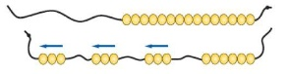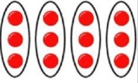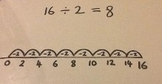

### MENTALSTRATEGIES:

* To know that division is the inverse of multiplication
* Recall division facts for the2,5 and 10 times tables
* Recall halves for even numbers up to and including20

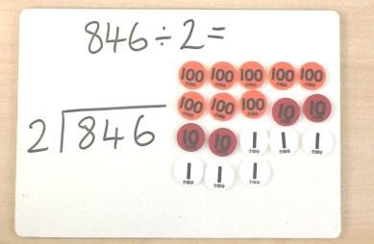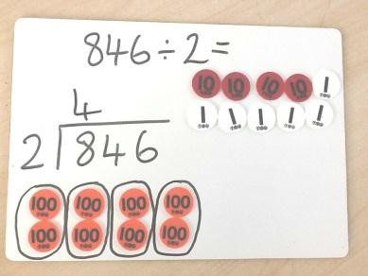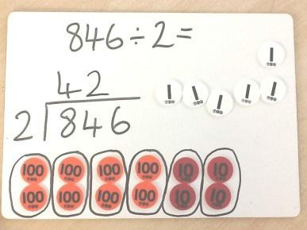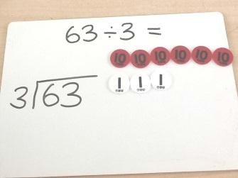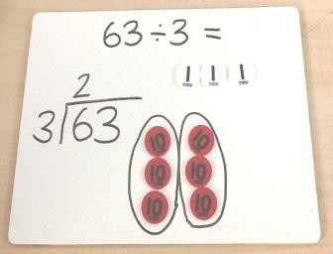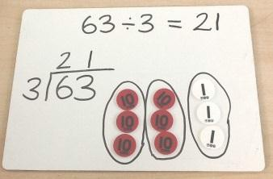



|  |  |
| --- | --- |
| **YEAR3:** | |
| **VOCABULARY:** divided by, divide, divided into, grouping, divisor, short division, remainder, inverse quotient  divisor)dividend | |
| **USEFUL VIDEOS:** | |
| **Method:** | **Example/Representation:** |
| Children will use practical resources to support the short division method and will be encouraged to use multiples of the divisor to assist. (TU÷ U) | Create the dividend using Place Value counters.  Group the tens counters according to the divisor and write the number of groups above the line in the tens column.  Groupthetenscountersaccordingtothedivisorandwritethenumberofgroupsabovethelineinthetenscolumn.  The quotient can be seen across the groups. |
| Children will use practical resources to support the short division method and will be encouraged to use multiples of the divisor to assist (HTU÷ U) | Create the dividend using Place Value counters.  Group the 100s counters according to the divisor.  Write the number of groups above the line in the hundreds column.  Next, group the 10s counters according to the divisor.  Write the number of groups above the line in the tens column. |

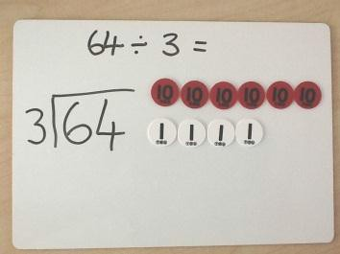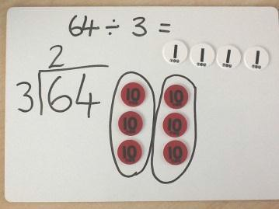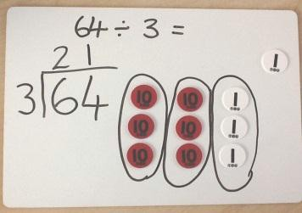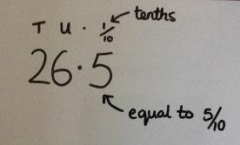

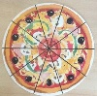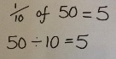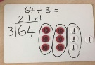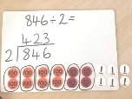

|  |  |
| --- | --- |
|  | Next, group the units counters according to the divisor. Write the number of groups above the line in the units column.  The quotient can be seen across the groups. |
| Children will use practical resources to support solving division number sentences with remainders. (TU÷ U) | Create the dividend using Place Value counters.  Starting with tens counters, group them according to the divisor. Write the number of groups in the tens column above the line.  Next, group the units according to the divisor and arrange next to the groups of ten. Write the number of groups above the line.  Any counters that cannot be grouped are the remainder. Write this at the end as ‘r1’.  As you look across each group, the quotient can be seen. |
| Pupils connect tenths to place value, decimal measures and that tenths is to divide by 10. | 1 10 |
| **MENTALSTRATEGIES:**   * Know the division facts from the 3,4 and 8 times tables * Use knowledge of place value to calculate division (e.g. 14÷ 2=7,140÷ 2=70, 1400÷2=700) | |

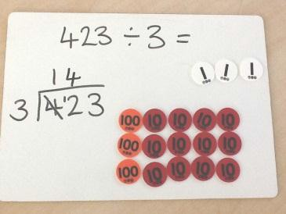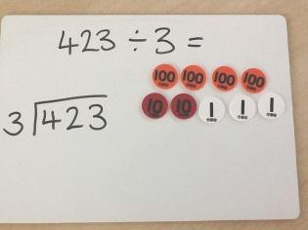

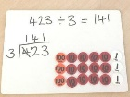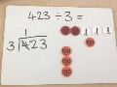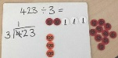

|  |  |
| --- | --- |
| **YEAR4** | |
| **VOCABULARY:** factor, divisor, divided by, divided into, remainders, divisible by ,equivalent, short division, derive, quotient, inverse, remainder, multiples, exchange quotient  divisor)dividend | |
| **USEFULVIDEOS:** | |
| **Method:** | **Example/Representation:** |
| Children will use practical resources to support the short division number sentences with remainders. (HTU÷ U) |  |
| Children will use practical resources to support the short division method where exchanges across place value column occurs. (HTU÷U) | Create the dividend using Place Value counters.  Group the hundreds counters according to the divisor. Write the number of groups above the line in the hundreds column.  Exchange the left over 100s counter for ten 10s counters and represent this beneath the line in the tens column.  Next, group the 10s counters according to the divisor and write the number of groups above the line in the tens column.  Group the units counters according to the divisor and write the number of groups above the line in the units column.  The quotient can be seen across each group. |



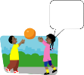

|  |  |
| --- | --- |
| Children will use the short division method where exchange across the place value columns occurs. Pupils will be encouraged to use multiples of the divisor to assist(HTU÷ TU). |  |
| Find the effect of dividing a 1 or 2-digit number by 10 and 100; identifying the value of the digits in the answer as units, tenths and hundredths. |  |
| Count up and down in hundredths; recognise that hundredths arise when dividing an object by a hundred and dividing tenths by ten. | 1.24 1.25  What should I cut my pizza into if I have got 100 people to serve? |
| **MENTALSTRATEGIES:**  - Know all related division facts for all times tables up to 12 times table (by the end of Year4)  - Use known facts when chunking e.g 483 ÷ 7 = (420 + 63) = 60 + 9 = 69 | |

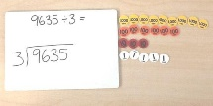

|  |  |
| --- | --- |
| **YEAR5** | |
| **VOCABULARY:** divide, divided by, divided into, divisible by, remainder, quotient, inverse, decomposing, factor, quotient decimal place, units, tenths, scaling, short division divisor)dividend | |
| **USEFULVIDEOS:** | |
| **Method:** | **Example/Representation:** |
| Children will use short division to solve division number sentences with remainders (HTU÷ TU) |  |
| Children will use practical resources to support solving division number sentences with remainders (ThHTU÷U) | Create the dividend using Place Value counters.    Group the 1000s counters according to the divisor and write the number of groups above the line in the thousands column.      Group the 100s counters according to the divisor and write the number of groups above the line in the hundreds column.    Group the 10s counters according to the divisor and write the number of groups above the line in the tens column. |



|  |  |
| --- | --- |
|  | Group the units counters according to the divisor and write the number of groups above the line in the units column. Express remainders as ‘r2’ as part of the quotient. |
| Children will learn to divide whole numbers and those involving decimals by 10, 100 and 1000 by moving the digits around the fixed decimal. |  |
| Children will start learning to use the long division method. | https://letsplaymath.files.wordpress.com/2010/04/long-division-4.png |
| Children will solve problems involving division, including scaling. |  |
| **MENTALSTRATEGIES:**   * Multiply and divide numbers mentally drawing upon known facts * Associate fractions with division | |

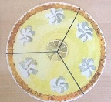

|  |  |
| --- | --- |
| **YEAR6** | |
| **VOCABULARY:** divide, divided by, divided into, divisible by, remainder, factor, quotient, inverse  quotient  divisor)dividend | |
| **USEFUL VIDEOS:** | |
| **Method:** | **Example/Representation:** |
| Divide numbers up to 4 digits by a two-digit whole number using the formal written method of division. |  |
| Interpret remainders as whole number remainders, fractions or decimals. |  |
| Divide numbers decimal numbers with up to 3 decimal places by 10, 100 and 1000 by moving the digits around a fixed decimal. |  |
| Divide proper fractions by whole numbers; proper fractions by proper fractions; mixed numbers by proper fractions. | 1 1  / ÷ 2= /  3 6 |
| **MENTALSTRATEGIES:**   * Use estimation to check answers to calculations and determine, in the context of a problem, levels of accuracy * Calculate a fraction of an amount | |