Dear parents,
Below are some of the things your child should be able to do at the end of this half term.
English:
Share old postcards, greetings cards, invitations. Help your child to learn your address. Encourage them to draw pictures and write letters to friends or family (you could even post them and ask the recipient to send your child a reply). Keep practising the new phonemes the children bring home each week to increase their confidence with reading and writing.
Maths: Try and introduce your child to shapes in the environment to develop their understanding that shapes are everywhere. Look at different objects around your home and see if your child can tell you the shape of the object (e.g. a clock face = circle, a pizza slice = triangle, a can of bean= cylinder) You can even begin to look at the straight sides or the pointed corners of the shapes. Continue to identify numbers at home, practise counting out different objects and looking at one more / one less.
Understanding the World:
The children should be able to discuss the times when they celebrate with their family, features of a celebration and the things that make a celebration a special occasion for their family. It would be useful for the children to look at photographs of family/friends’ celebrations (maybe wedding photographs, birthday parties, religious festivals etc.) and talk about what made the celebration special – if your child was there, encourage them to describe what they can remember.
Topic:
Celebrations
Weblinks:
www.topmarks.co.uk
www.phonicsplay.co.uk
www.letters-and-sounds.com
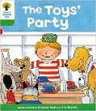
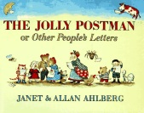
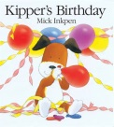
Books:
Kipper’s Birthday – Mick Inkpen
The Jolly Postman – Janet & Allan Ahlberg
The Toys party

