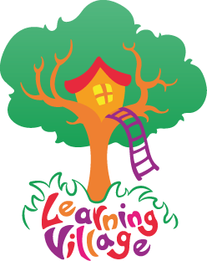

Dear Parents,

We have access to a programme of learning which will support your child’s speaking, listening, reading and writing development.

The website address is: www.learningvillage.net

our username is: Engayne1

our password is: Engayne12!

After login, your learner will see a map with icons flashing. They must click on an icon and proceed to assess and continue with the lessons.

Use this link which helps navigate the site.
https://www.youtube.com/embed/9AgUdVL-L20?rel=0?q3t0x6

If you have any questions, please don’t hesitate to contact me.

Miss Mills
Year3 Engayne Primary School

