Engayne Primary School
SEND Information Report

Contents Page
Page Number | Content
3 | The Staff
4 | The four main areas of SEND
5 | The Graduated Approach for children with SEND
6 | Identifying and assessing children with SEND
7 | What does it mean if my child is on the SEND register.
8 | The SEND register process
9,10 | Passport Example
11 | Communication and Interaction
12 | Cognition and Learning
13 | Social, Emotional and Mental Health
14 | Physical and Sensory
15 | Medical Needs
16 | Involving Parents and pupils
17 | Links to Local Offers

The Staff
The class teacher is the person who spends the most time with the individual students and will have the biggest influence on them. They will usually be your first port of call for any concerns you have.
Photographs of all the teachers can be found on the school website

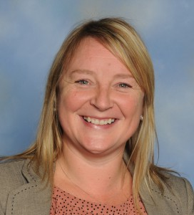
Mrs Sankey is the Head teacher and oversees the progress and intervention for all the children.
We have currently have 17 Teaching assistants working at Engayne.
They run interventions and support children in the classroom.
Mrs Marsh is the SEND admin support.
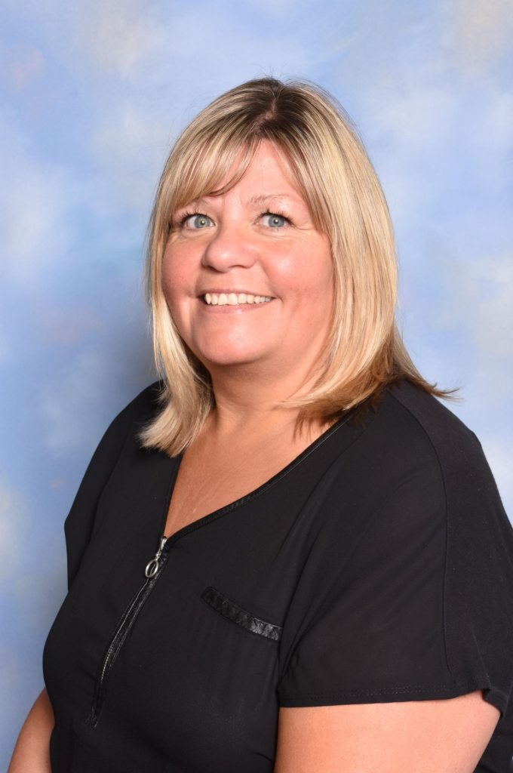Mrs Marsh is the office
support for SEN.
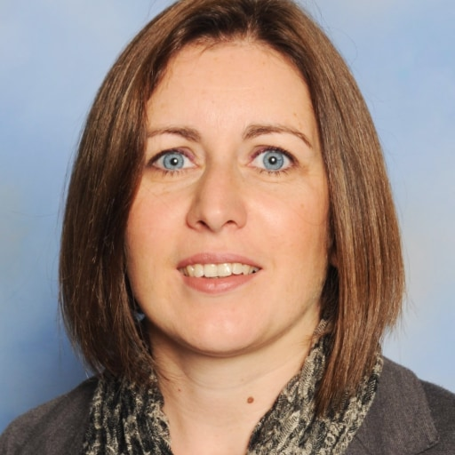
Liz Birchall is the SENDco. She oversees all of the SEND provision by liaising with teachers, teacher assistants, parents and outside agencies; providing training and monitoring intervention and progress.
Denise Whalley is the SEND Governor.

The four Broad areas of Need
The SEND Code of Practice 2014 identified four main areas of need:

At Engayne, we identify and support children across all four areas of need.
THE GRADUATED APPROACH FOR SEND PUPILS

How do we Identify and assess children with SEND?

What does it mean if my child is on the SEND register?
Many children in school, of all different abilities, receive extra support to help them to make progress. Teachers differentiate their lessons so children have work that they find challenging but achievable. Groups go out to work on specific skills, such as reading, writing, handwriting or maths skills. Teachers and Teaching assistants focus on specific children within a lesson to help them move on to the next stage. Teachers give the children feedback that they have to respond to, so they can improve their work.
All children learn at a different pace. If a child needs support that is different from or additional to the support provided in class they will be put on the SEND register. See the process on the following page.
Trained members of staff accompany children with SEND or medical needs on school trips. Individual needs and support will be planned for each trip and will form part of the risk assessment. Support will also be put in place for before/after school clubs run by the school. If your child attends a club run by an outside provider please liaise directly with them and inform them of your child’s needs.
The SEND register Process

passport example

Name: |  |  | PRIMARY PUPIL PASSPORT /IEP
D.O.B: | Photo of child  SEND code:  This will be either School Support or EHCP
NC year group: |  | SENDCO: Liz Birchall | Year: 2019-2020
Access Arrangements |  | A brief outline of your child’s main needs / barriers to learning.  These columns will be deleted / amended depending on the needs of your child. | Term Reading Writing Maths Toe by toe Phonics test /40 Toe by toe Reading test Age  Autumn  Spring  Summer  Term Book Band Booster Phonics stage: Phase: Toe by Toe: HFW Phase: 1st/2nd 100 words Read/Spell Number sorrespondence  Autumn  Spring  Summer
Care plan:
If your child also has a HCP it will be referenced here.
ATTENDANCE
 | PreSENDt | Late
Autumn
Spring
Summer

It would help me if you could  - A list of adaptations made in the class to meet your child’s needs. Eg differentiated work, check lists, visual prompts, writing slopes, chunking of work etc.  - This will include recommendations made by outside agencies where relevant. | Additional Support / Provision  - A list of intervention that your child receives.
The Term IPP Targets
Name: |  |  |  | Class: |  |  |  |  |  |  | Date: |  |  |  |  |  |  | TA: name of teaching assistant.
Target | ENTRY  DATA | DATE  9/9 | DATE  16/9 |  | DATE  23/9 | DATE  30/9 | DATE  7/10 | DATE  14/10 | DATE  28/10 | DATE  5/11 |  | DATE  4/11 | DATE  18/11 | DATE  25/11 | DATE  2/12 | DATE9/12 | EXIT DATA |  | Comment  Met/Partially met
LONG TERM TARGET  A specific, measurable, achievable and relevant target. |  |  |  |  |  |  | T | T | T | A |  | A | A |  |  | R |  |  | A review of if the target has been met or partially met. If it has been partially met, then a more detailed explanation is needed.
SUCCESS CRITERIA
More specific detail of what we expect for us to consider that this target has been met eg: 80% accuracy in targeted sessions
LONG TERM TARGET |  | Targets from reports from outside agencies or EHCPs will be transferred to the passport. |  |  |  |  |  |  | A weekly record of whether the target has been taught (T), achieved(A) or retained (R).
SUCCESS CRITERIA

LONG TERM TARGET

SUCCESS CRITERIA

LONG TERM TARGET

SUCCESS CRITERIA

Communication and Interaction

Cognition and Learning

Social, Emotional and Mental Health

Sensory and Physical needs

Involving Parents and Pupils
PASSPORT MEETINGS – If your child has a passport, once a term you will be invited to meet with the SENDco and the class teacher. This will replace the parents evening meeting. It is a longer session where you will be able to give your views on the targets, provision and progress. However, if you have any concerns don’t wait for the meeting, please let the class teacher or SENDco know. We can then look into how we can support your child differently. You can contact us via email ‘contact@engayne.co.uk’ or by phoning the school office and leaving a message (01708 223492).
HEALTH CARE PLAN MEETINGS – initially parent/carers will meet with the school nurse to write the HCP. Each year you will be asked to review the HCP. If any changes need to be made, you will be invited in for a meeting with the school nurse. Please keep us up to date with any changes to your child’s health needs.

Local offer Links
To find out more about what support is available for children with SEND please click on the link below:
https://familyserviceshub.havering.gov.uk/kb5/havering/directory/localoffer.page?localofferchannel=0

