Week beginning 15th June
Hi all of you!
This week, some of us would have been getting ready for our PGL trip or looking forward to taking part in exciting activities at school but we will have to be patient and wait until next year!
Your challenge for this week is to pack 6 items in a suitcase and only 6! You must tell us why you have chosen these 6 items. Have fun!

The Y5 team

English: Mobile Home
https://www.pobble365.com/mobile-home/

Story starter!
They had always wanted to travel around the World, but didn’t think they would end up doing it like this!
Having lived in their home in Goose Farm for only 2 years, the Jackson family had made a final decision to leave. It had been a tough decision for them, but with all the trouble they had caused in the town, they felt it was the right time to go. Nothing had gone as planned, even the house was falling apart.

Putting the wheels on the house wasn’t the hardest part for Tom, it was trying to fit everything in. It was midnight when they left so that no one saw them leave. Or that’s what they thought…

Question time!
If you could live anywhere, where would it be? Why?
If you could only take 3 things with you on a journey, what would they be? Why?

Sentence challenge!
Can you use adverbs to describe how Tom created his house?
Slowly, Tom lifted the massive wheels onto the axle.
Carefully, he bolted the wheels to the chassis.

Sick sentences!
These sentences are ‘sick’ and need help to get better. Can you help?
The house drove along the road.
Tom put the wheels onto the house.

Perfect picture!
Where do you think the house is going? Can you draw a map of its journey showing the places it travels past?

Maths:
We are continuing our journey that began with measures and moved through to shapes. This week we are looking at angles as properties of shapes, building upon our knowledge of what angles are.
N.C objectives:
- Know angles are measures in degrees
- Estimate, measure, draw, compare and describe angles as acute, obtuse and reflex
- Know that 1 whole turn = 360º
- Know that ½ turn, an angle on a straight line = 180º
- Know that a right angle = 90º
- Use properties of rectangles and triangles to find missing angles and lengths
- Identify regular and irregular polygons based on reasoning about angles and edges.

Activities:
- Measuring Angles
- Rectangles and irregular polygons
- Angles 3
- Angles 4
- Daily TTrockstars and NumBots (These skills are essential to solve problems)

Challenge Questions.

Q1.
Estimate the size of angle x
Circle the closest estimate.
170° 310° 190° 260° 180°

Q2.
This is a rectangle with its two diagonals.
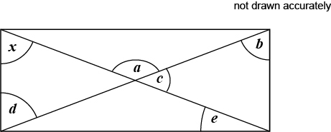
Angle x = 58°
Circle the two angles that are the same size as angle x
a b c d e

Q3.
Layla completes one-and-a-half somersaults in a dive.
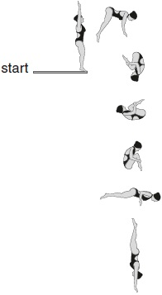
How many degrees does Layla turn through in her dive?
1 mark
Q4.
Here is a regular octagon.
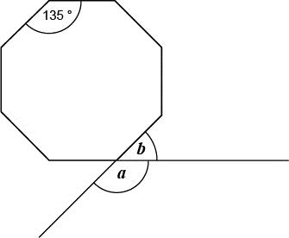
Calculate the sizes of angles a and b
Q5.
Calculate the size of angle p in the diagram.
Do not use a protractor (angle measurer).
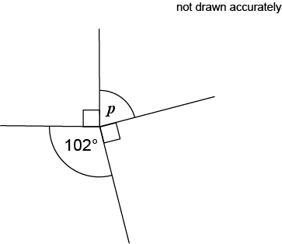
2 marks

Science:
We hope you have had fun so far designing a cardboard boat and creating your spaghetti bridge.
Your next challenge.
Cardboard Chair
Construct a chair that you can sit on using only cardboard. No glue, tape or other fixing materials allowed.
- Write down or sketch some ideas as to how you will construct the chair.
- Think about how you can join the cardboard together using strips, spirals or tubes.
This will require some top scientific/engineering thinking. Please send us your pictures.
Remember if it doesn’t work the first time do not give up! Try again

Topic Work –
Art: Start to build your external frame of your shelter. Think about how it should look inside and out and how you will add details.
Geography: Continue with your South America Animals project. You might want to start thinking about fun facts and even sketching illustrations of the animals.
PE: Build an assault course in your garden or in your room. Plan different activities at each station.

Music:
Login into Charanga using the login details below. Have a go at singing the song and complete the fun activities. Can you get your family to join in with you?
Navigate to - https://charanga.com/site/log-in/
Scroll to ‘student login’.
Username: p917568
Password: cadence
Childline
08001111

